

**Design Document for:**

**Murdoch and Monsters**

**M&M**

“Something funny here or not so funny!”™

All work Copyright © 2021 by Team Mysterios

Written by all members of Team Mysterios

Version # 2.1

Friday, October 29, 2021Table of Contents

**Design History** **4**

**Version 1.0** **4**

**Version 2.00** **4**

**Version 2.10** **4**

**Game Overview** **5**

**Philosophy** **5**

**Philosophical point #1** **5**

**Philosophical point #2** **5**

**Common Questions** **5**

**What is the game?** **5**

**Why create this game?** **5**

**Where does the game take place?** **5**

**What do I control?** **5**

**How many characters do I control?** **5**

**What is the main focus?** **5**

**Feature Set** **6**

**General Features** **6**

**Editor** **6**

**Gameplay** **6**

**The Game World** **7**

**Overview** **7**

**Familiar yet different environment** **7**

**World Feature** **7**

**The Physical World** **7**

**Overview** **7**

**Key Locations** **7**

**Travel** **7**

**Scale** **7**

**Objects** **7**

**Rendering System** **8**

**Overview** **8**

**2D/3D Rendering** **8**

**Camera** **8**

**Overview** **8**

**Camera Detail #1** **8**

**Camera Detail #2** **8**

**Game Engine** **9**

**Overview** **9**

**Game Engine Detail #1** **9**

**Game Engine Detail #2** **9**

**Collision Detection** **9**

**The World Layout** **10**

**Overview** **10**

**World Layout Detail #1: Simplistic design** **10**

**World Layout Detail #2: linear design** **10**

**Game Characters** **11**

**Overview** **11**

**Creating a Character** **11**

**Enemies and Monsters** **11**

**User Interface** **12**

**Overview** **12**

**User Interface Detail #1 - player selection** **12**

**User Interface Detail #2 - turn order** **12**

**User Interface Detail #3 - Enemy attack selection** **13**

**User Interface Detail #4 - level cleared screen** **13**

**User Interface Detail #5 - Game cleared screen** **13**

**User Interface Detail #6 - “You lost” screen** **14**

**Single-Player Game** **15**

**Overview** **15**

**Single Player Game Detail #1: Intuitive UI** **15**

**Single Player Game Detail #2 Dice rolling** **15**

**Single Player Game Detail #3 Multiple Character Selection** **15**

**Story** **15**

**Hours of Gameplay** **15**

**Victory Conditions** **15**

**Character Rendering** **16**

**Overview** **16**

**Character Rendering Detail #1** **16**

**Character Rendering Detail #2** **16**

**Geometry defines how object3D data types are displayed using OpenGL.** **16**

**World Editing** **16**

**Overview** **17**

**World Editing Detail #1: Random level choice.** **17**

**World Editing Detail #2: Easily editable maps** **17**

**“Objects Appendix”** **18**

**“User Interface Appendix”** **20**

# **Design History**

This section, design history, is about the changes this document has gone through during the production of our game ‘Murdoch and Monsters’. It details the changes made between each version giving an idea of how it became the current document.

## **Version 1.0**

Version 1.00 is the draft version of the design where all ideas were supported by concepts.

1. We briefly described each section to cement our thoughts.
2. We included rough sketches of the UI, level layout.

## **Version 2.00**

Version 2.00 is the first official version of the design where a major revision was made now that much more is known about the game. After many hours of design and development, many decisions have been finalised. Most of these large design decisions are now reflected in this document.

Included in the changes are:

1. Refined game scope
2. More detailed descriptions in many areas
3. World layout and design.
4. final UI layout.

## **Version 2.10**

Version 2.10 has several small changes over that of version 2.00. The key areas are in many of the appendixes.

Included in the changes are:

1. Minor revisions throughout the entire document.
2. Added “User Interface Appendix”.
3. Added “Game Object Properties Appendix”.
4. Added concept sketches for the game world.

# **Game Overview**

## **Philosophy**

### **Philosophical point #1**

The game is trying to show what can be accomplished using OpenGl by creating a simple dungeons and dragons spin off.

### **Philosophical point #2**

Our game only runs on Windows computers. The reason for this is accessibility.

## **Common Questions**

### **What is the game?**

Murdoch and Monsters is a dungeon and dragons type game focused around a tile based system linked to a turn based system.

### **Why create this game?**

This game was created for ICT290 at Murdoch university and the idea was common among the team.

### **Where does the game take place?**

Murdoch and Monsters takes place at Murdoch University around the bush court. The idea is that students have wandered onto campus during an eerie time and there are mushrooms and chains in bush court. These students wander into the Physics Sciences building to be forced to select a D&D class to battle their way through the dungeon to uncover what has happened.

### **What do I control?**

Players walk in bush court vai the arrow key and A/Q to look up and down respectively along with Z/X to look left and right. When in the game you can move your character with WASD.

### **How many characters do I control?**

Players can control up to 15 characters as the game dynamically sets the players to the game list.

### **What is the main focus?**

Players are tasked with defeating all enemies on the level allowing players to progress through the game until they reach level 10.

# **Feature Set**

## **General Features**

Medium world

Mutant enemies

Typical adventure characters (archer, warrior, mage)

3D graphics

32-bit color

## **Editor**

Character stats editor

Class editor

Ability Editor

Enemy Editor

enemiesPerLevel editor

map editor

## **Gameplay**

Adventure aesthetic

Turn based movement

health

Character selector

Character stat modifier

Character upgrade

# **The Game World**

## **Overview**

The game world is based around Murdoch University, with a dark mysterious twist. The world will feature the bush court and the physical sciences building. The world will have a tiled effect to it showing how far objects are from the player (turn based game).

## Familiar yet different environment

The world is originally based at Murdoch University’s bush court and physical sciences building but it seems dark and mysterious, like it’s hiding something.

## **World Feature**

Turn based combat system based on a dynamic level generation system and offer a large selection of classes and enemies.

## **The Physical World**

### **Overview**

The world resembles Murdoch’s bush court and physical sciences building where you can access the game world which represents a sealed dungeon.

### **Key Locations**

The game is set in Murdoch University's bush court and Physical Sciences building.

### **Travel**

Players use Arrow keys to move around bush court and WASD to move around the dungeon.

### **Scale**

Scale is not set to be realistic as all characters are the same size of the walls. All this is to allow players to easily see the characters.

### **Objects**

The objects in the game are a mix of OpenGL objects and .obj files. The .obj files are used for the vegetation on bush court and all objects in the game levels. See Objects Appendix for more information

## **Rendering System**

### **Overview**

The game will be rendered using OpenGL. The game space will render to the screen with objects being drawn using a series of triangles. The fixed function pipeline would be the set of functions undertaken by OpenGL inorder to render the game.

### **2D/3D Rendering**

The 2D and 3D rendering is to be handled by using the OpenGL cross platform API that allows for real time rendering. The context to display our rendered game would use Freeglut, as it can easily create windows.

## **Camera**

### **Overview**

The camera will be a class in C++ that will control all the aspects of the camera like movement and rotation. It will also check whether or not the camera has the ability to move eg collision detection. The initial positioning of the camera would also be dealt with inside of the camera class.

The Camera system can be summarised into these three main things

1. Control the camera
2. Rotate the camera
3. Move and respond to collisions

### **Camera Detail #1**

The Camera movement works by moving the camera in the current direction it is facing. The movement is determined by a variable that accounts for its step size. This is a variable that can be set and changed. The direction of the camera is set by the user by pressing buttons to rotate it.

### **Camera Detail #2**

The Camera can be prevented from moving by checking if it is intersecting with bounding boxes. The camera is itself responsible for preventing the player from going to places where it shouldn’t be inside of the game world.

## **Game Engine**

### 

### **Overview**

The game engine initiates itself when the player enters the game portal. It controls the entirety of the game loop and reinitialization of the game loop during newer levels.

### **Game Engine Detail #1**

The game will keep track of the hp of the characters on the game field, removing them when a character or enemy hp <= 0.

### Game Engine Detail #2

Enemy AI will be controlled by the game engine. During one of the enemy’s turns, the enemy AI will wake up and execute the following.

* If player is not in range of abilities
  + move
    - while enemy has movement check for players in range
      * if in range
        + attack

end turn

* + - if enemy has no movement
      * end turn
* If player is in range of abilities
  + attack
    - end turn

### **Collision Detection**

Due to using a grid for movement, it is a simple check towards the tile that the entity desires to move through. If there is another entity or a wall, you can't move there. No movement is expended.

# **The World Layout**

## **Overview**

The world will consist of a grid map surrounded by walls. The maps would have differing sizes and specialised patterns of walls to help make each map more unique.

## **World Layout Detail #1:** Simplistic design

The game’s simplistic design helps make the focus be more on the player’s characters and enemies rather than the void that the map is placed in.

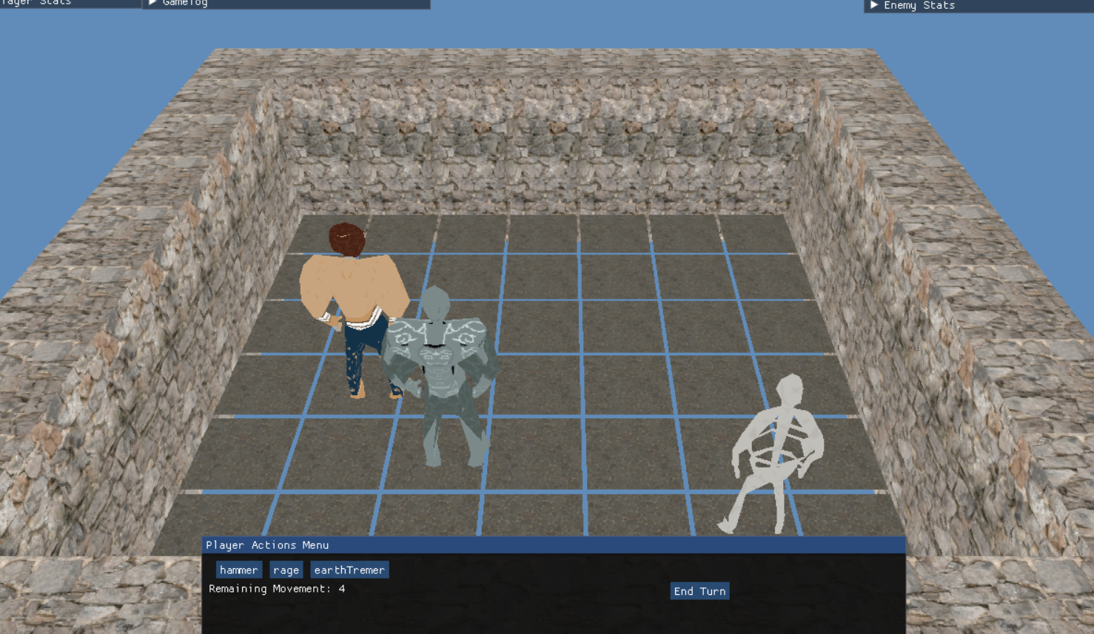

## **World Layout Detail #2:** linear **d**esign

All textures are similar in nature so as to not alienate the player’s focus from the game.

# **Game Characters**

## **Overview**

Characters that can be added into the player’s party consists of archetypes that can be found in 5th edition Dungeons and Dragons

## **Creating a Character**

When entering the lobby for the game, the player is prompted with a screen showcasing a player model, its class name, and a black name slot. Players are advised to choose a character class and name it, after which they are to add them to their party. The player can have as many characters as they want in their party.

## **Enemies and Monsters**

Enemies chosen are creatures that exist from within the Monster compendium for 5e DnD. The monsters however will be simple as to adhere to the grid based design.

# **User Interface**

## **Overview**

The user interface is created by using the ImGUI library. The UI includes a player selection, turn order, player stats, enemy stats, combat log, action menu.

## **User Interface Detail #1 - player selection**

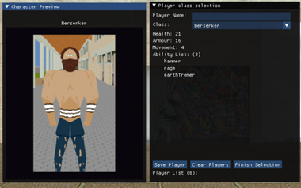

## **User Interface Detail #2 - turn order**

# 

## User Interface Detail #3 - Enemy attack selection

# 

## User Interface Detail #4 - level cleared screen

# 

# User Interface Detail #5 - Game cleared screen

# 

# 

# User Interface Detail #6 - “You lost” screen

# 

# **Single-Player Game**

## **Overview**

The game should play like a regular game of dnd, in that the game should be a team based turn-based rpg which uses a D20(20 sided die) to determine all actions but movement.

## **Single Player Game Detail #1:** Intuitive **UI**

This well recognised UI should be able to allow players to easily understand as to what to do and what resources that they have available to do it

## **Single Player Game Detail #2** Dice rolling

Functioning dice roller to have that authentic DnD feel of rolling dice, albeit with only the D20.

## Single Player Game Detail #3 Multiple Character Selection

Players can choose between a wide variety of characters to add to their party.

## **Story**

The player plays an adventuring party who desires to delve into the depths of ruins which had held up Murdoch Uni since its founding. The secrets beckon so sweetly, but is it worth the bodies to path the way to unravel this delectable secret.

## **Hours of Gameplay**

The game should take approx. 15-30 minutes per run. This should be enough for a game which essentially is similar to a boss rush, in that it is a continuous cycle of battles in a dungeon until the players reach the depths.

## **Victory Conditions**

The player wins when all levels are cleared with the player having at least 1 surviving player.

# C**haracter Rendering**

## **Overview**

Characters are rendered through reading a .obj file and then stored in a custom object3D file type that stores faces, vertices and vertex normals. This object3D object is then read by a custom OpenGL draw function that loops through all vertices of the object3D.

## **Character Rendering Detail #1**

ReadOBJFile defines how the .obj files are stored and takes an address to an object3D data type defined in Geometry.

## **Character Rendering Detail #2**

## Geometry defines how object3D data types are displayed using OpenGL.

# **World Editing**

## **Overview**

The maps for each level can be made simply by listing a box full of 1’s and 0’s. 1’s will indicate walls and 0’s will indicate a free space.

## **World Editing Detail #1:** Random level choice.

Levels past level 3 will have a set list of maps to choose from and will be randomised on each run. This will mean that each new run will be a fresher experience than the last playthrough.

## **World Editing Detail #2: Easily editable maps**

The maps, due to their simplicity, are easily altered with a small change from 0’s to 1’s. Because of this, it is easy to create new maps as it is simply flooding a set amount of excel tiles with 0’1 and 1’s.

# 

# **“Objects Appendix”**

| Original Character sample  Skeleton |
| --- |
| Zombie |
| AnimatedArmor |
| Shadow |
| AirElemental |
| WaterElemental |
| EarthElemental |
| FireElemental |
| AirGolum |
| WaterGolum |
| EarthGolum |
| FireGolum |
| AirMage |
| WaterMage |
| EarthMage |
| FireMage |
| TelekineticMage |
| SummoningMage |
| TrapEnt |
| LavaGoblin |
| AirBoss |
| WaterBoss |
| EarthBoss |
| LavaBoss |

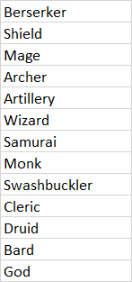

tree

chainedTree

red mushroom

brown mushroom

rock

bush

dungeonPillar

dungeonFloor

deadTree

dyingTree

stun

Portal

# **“User Interface Appendix”**

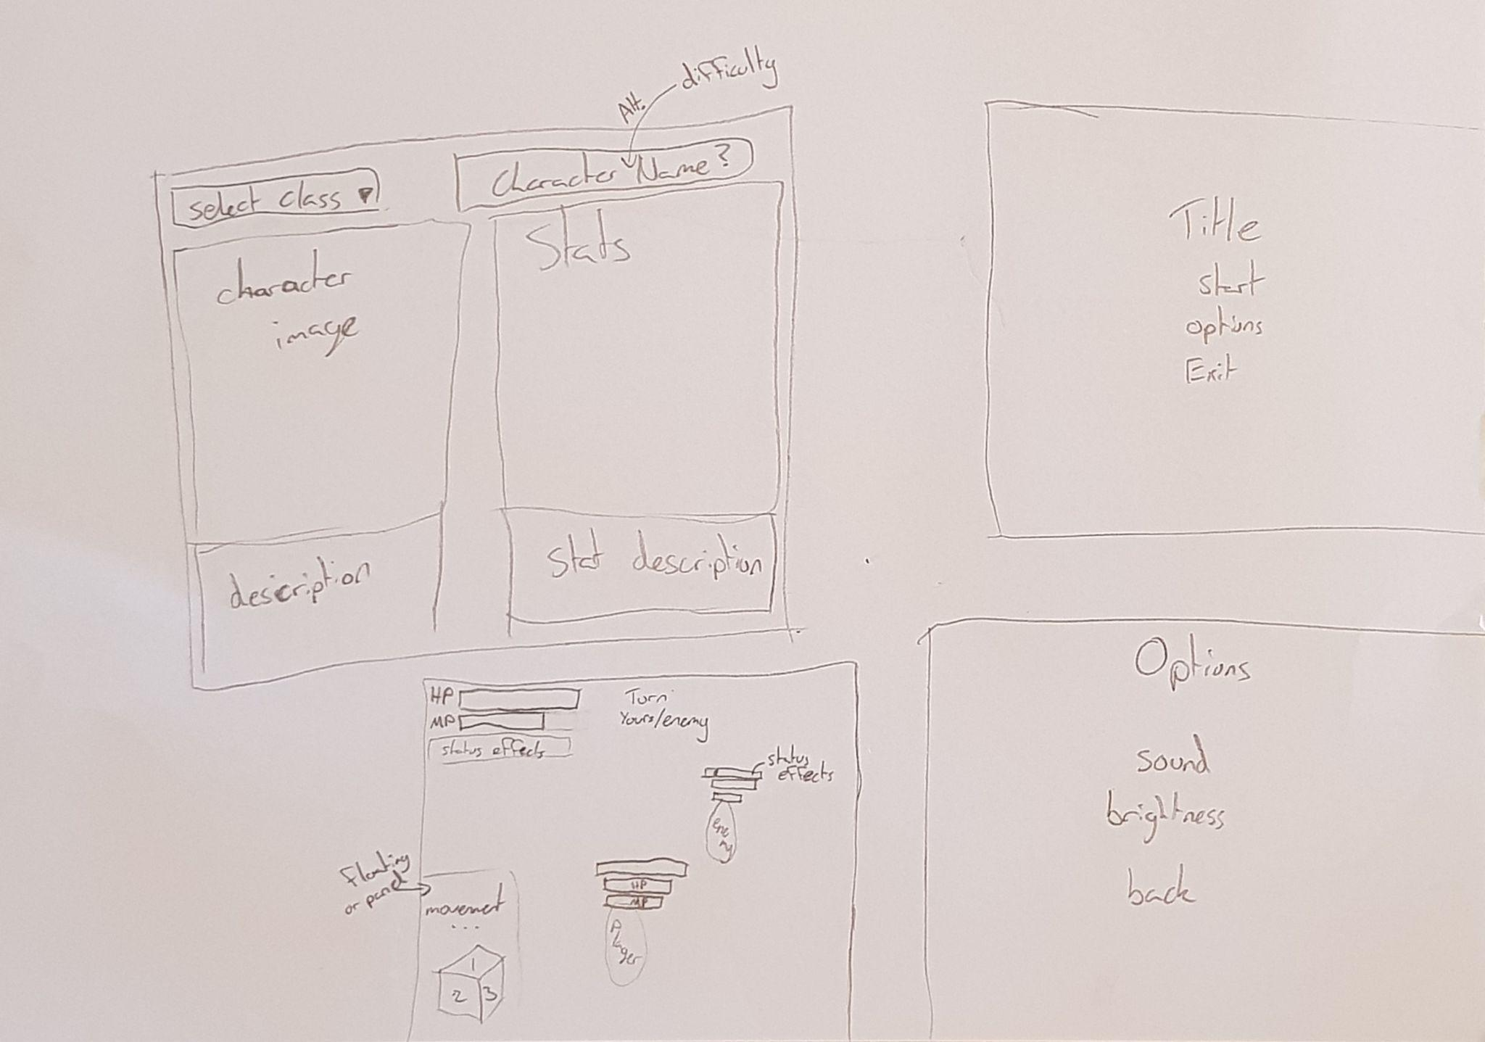

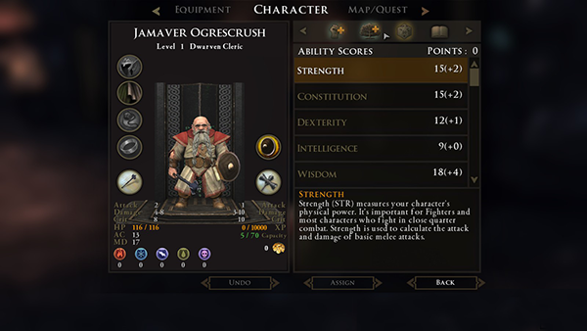

*Figure 2: Sample UI art style,* <https://www.behance.net/gallery/9506369/Dungeons-Dragons-Daggerdale-Graphic-Design>